Name____mike moncoeur_____________________________ 01.05 String Input
This assignment has three parts.
Part One: Write a program to simulate a chatbot conversation. Use the following guidelines to write your program:

- Decide on an interactive conversation someone could have with a computer.
- Your program should include at least three interactive prompts.
- Input from the user should be assigned to variables and used throughout the conversation.
- At least once, use the indexing or slicing technique.
- Use concatenation to join string literals and string values.
- Write the pseudocode for this program. Be sure to include any input and output needed.

Insert your pseudocode here:
Pseudocode:
Input:
The name of the computer
The Type of keyboard
Mouse
Speaker

Output:
Display a message the computer details, including the name, keyboard , mouse and speaker.

Part Two: Code the program. Use the following guidelines to code your program.

- Code the program using Python IDLE.
- Using comments, type a heading that includes your name, today’s date, and a short description of the program.
- Use meaningful names for all variables.
- Follow the Python style conventions regarding indentation and the use of white space in your program.

Example of expected output: The output for your program should resemble the following screen shot. Your specific results will vary depending on the choices you make about the conversation and the input provided.
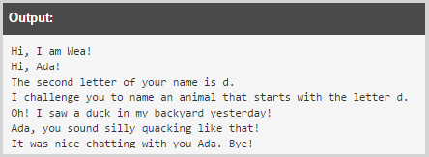

Insert a copy of your code from the IDLE here:
# mike moncoeur
# 3/22/2019
# print conversation with ada and wea

def main():
print("hi, my name is wea!")
print("hi, ada!")
print("the second letter of your name is d.")
print("i challenge you to name an animal that starts with letter d.")
print("oh! i saw a duck in my backyard yesterday!")
print("Ada, you sound silly quacking like that!")
print("it was nice chatting with you ada. bye")

main()

Part Three: Complete the Post Mortem Review (PMR). Write thoughtful two to three sentence responses to all the questions in the PMR chart.
Review Question | Response
What was the purpose of your program? | Conversation with ada and wea
How could your program be useful in the real world? | Well it will change the way of conversation.
What is a problem you ran into, and how did you fix it? | Well this time I took my time and did everything right.
Describe one thing you would do differently the next time you write a program. | Well next time I’ll try to make it shorter.

